NAMA: KHASNA NADIYA

NIM:42423036

PRODI: INFORMATIKA/3

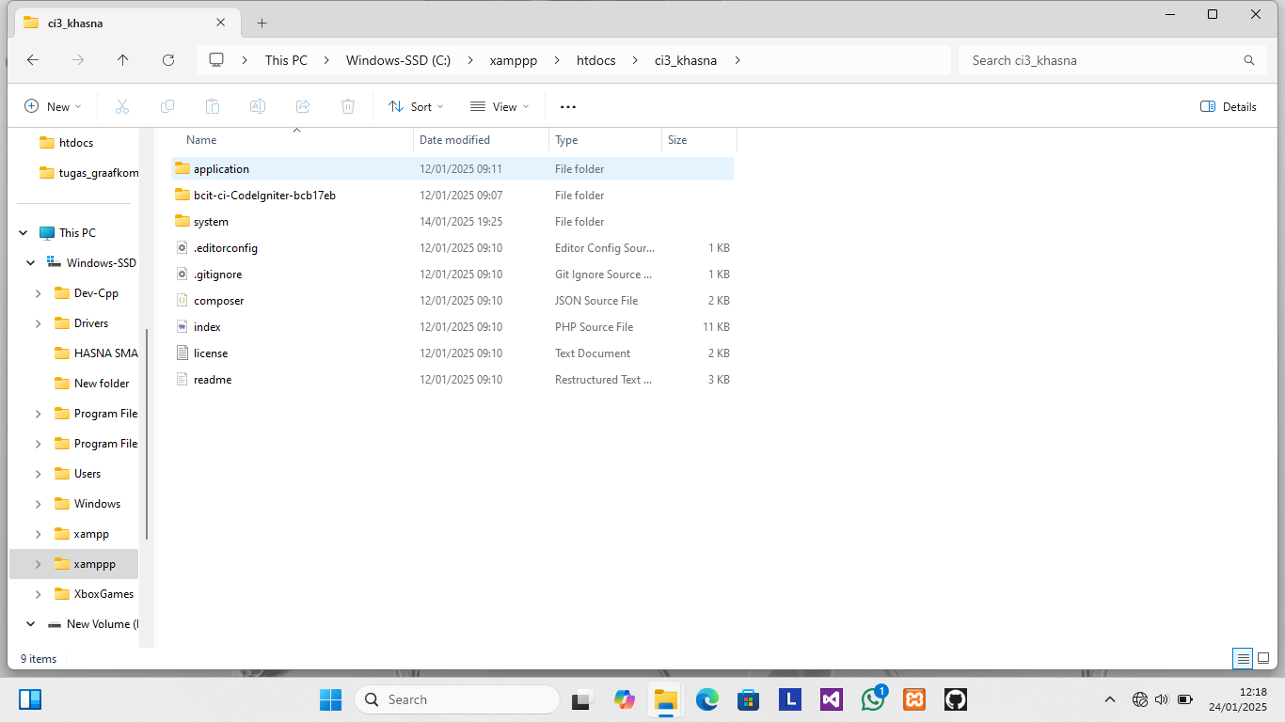

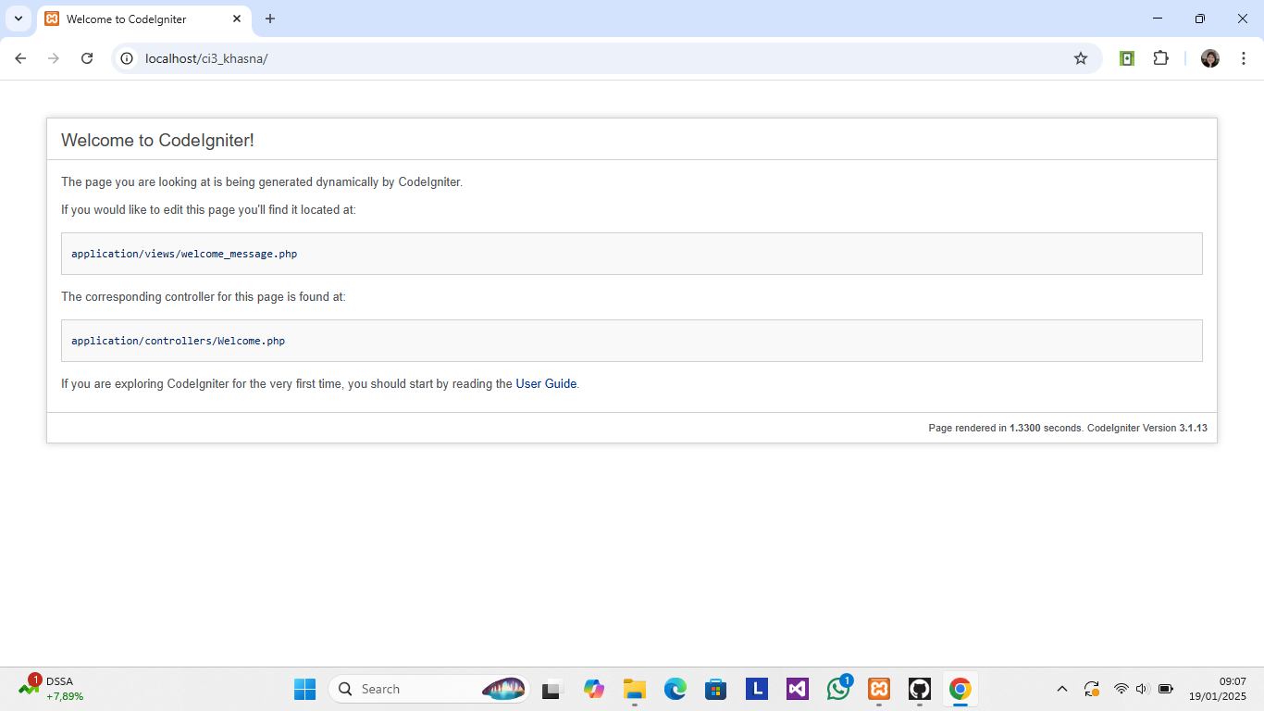

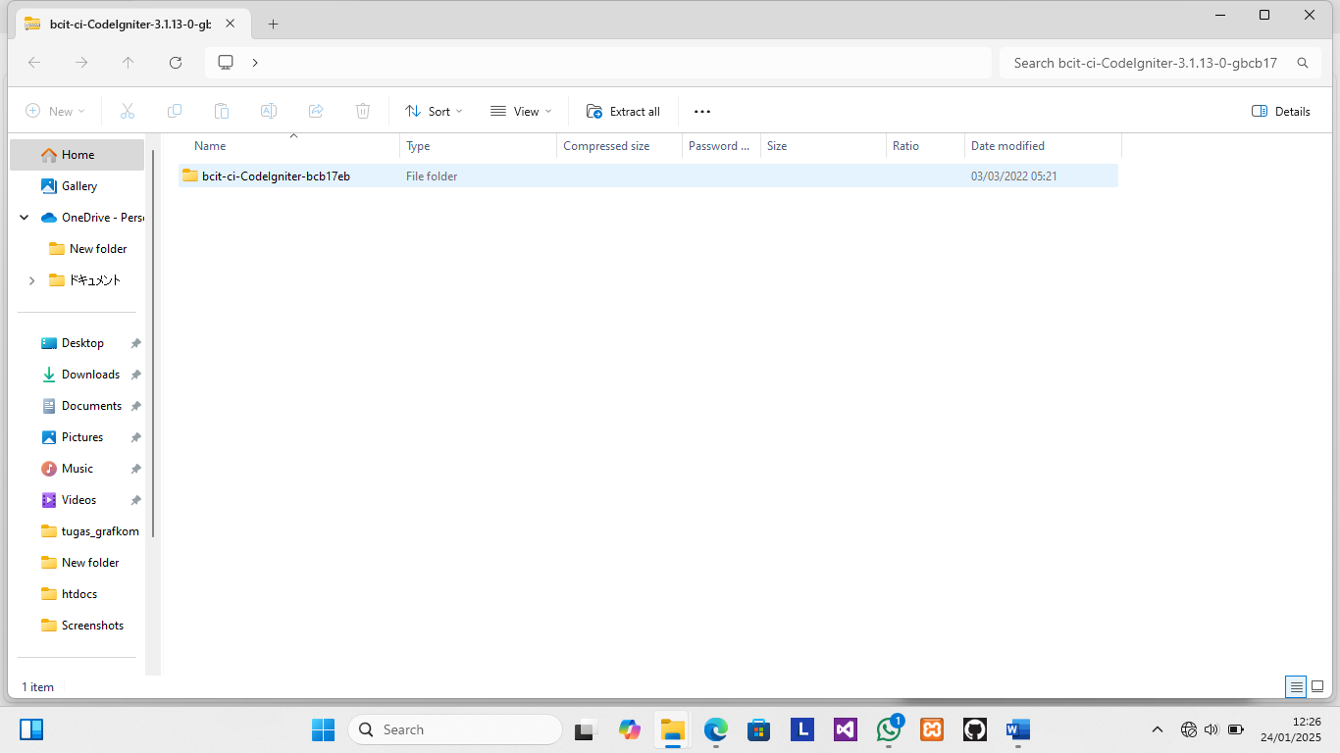

https://codeload.github.com/bcit-ci/CodeIgniter/legacy.zip/refs/tags/3.1.13